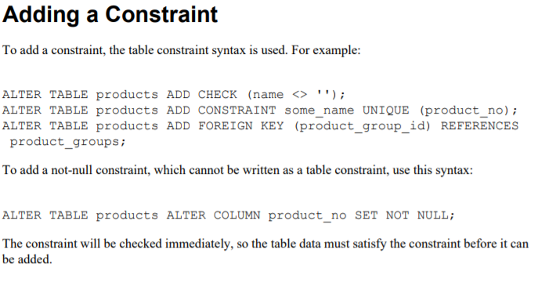

Source: [PostgreSQL Documentation](https://www.postgresql.org/files/documentation/pdf/14/postgresql-14-A4.pdf)